**VIETNAM NATIONAL UNIVERSITY - HO CHI MINH CITY**

**INTERNATIONAL UNIVERSITY**



**MENTAL HEALTH IMPACTS OF THE COVID - 19 PANDEMIC**

**INSTRUCTOR: Đặng Đức Dũng**

**VIETNAM NATIONAL UNIVERSITY - HO CHI MINH CITY**

**INTERNATIONAL UNIVERSITY**



**MENTAL HEALTH IMPACTS OF THE COVID - 19 PANDEMIC**

**INSTRUCTOR: Đặng Đức Dũng**

**TABLE OF CONTENT**

1. **INTRODUCTION………..…………..……..……...……….…1**
2. **METHOD...………………………………..……..………..…….3**
3. **RESULTS………………………………..…………..………..….12**
4. **SUGGESTIONS…………………………..…………..……..…13**
5. **CONCLUSION…………………………..……………..……….17**
6. **REFERENCE………………………………..…………..……….19**
7. **APPENDIX…………………………………..……………..…...20**
8. **INTRODUCTION**

A pandemic is not merely a medical phenomenon; it impacts people and society and generates disruption, worry, stress, stigma, and xenophobia. The conduct of an individual as a unit of society or a community has notable implications on the dynamics of a pandemic that includes the amount of severity, degree of flow, and aftereffects. Rapid human‐to‐human transmission of the SARS‐CoV‐2 led to the installation of regional lockdowns to halt the further spread of the illness. Isolation, social isolation, and closure of educational institutions, businesses, and recreational venues sentenced individuals to remain in their homes to help break the chain of transmission. However, the restrictive restrictions surely have damaged the social and emotional health of people from across the board.

As more and more individuals are compelled to remain at home in self‐isolation to prevent the further spread of the disease at the social level, governments must take the required steps to give mental health care as suggested by the specialists. Professor Tiago Correia underlined in his editorial that the health systems globally are gathering entirely to battle the COVID‐19 epidemic, which might dramatically impair the treatment of other illnesses like mental health, which normally exacerbates during the pandemic. The psychological condition of an individual that contributes toward community health differs from person‐to‐person and relies on his history and career and social status.

Quarantine and self‐isolation may most likely create a detrimental influence on one's mental health. A study published in The Lancet indicated that the separation from loved ones, loss of independence, boredom, and uncertainty might cause a worsening in an individual's mental health situation. To address this, measures at the individual and society levels are necessary. Under the present global circumstances, both children and adults are experiencing a variety of emotions. They may be put in a setting or an atmosphere that may be novel and might be potentially detrimental to their health.

1. **METHODS**
2. **Participants**

A total of 168 respondents from various academic backgrounds and affiliations with different universities in Ho Chi Minh City participated in the study. The breakdown of participants included students from Ho Chi Minh City University of Science, Ho Chi Minh City University of Social Sciences and Humanities, Ho Chi Minh City University of Foreign Languages and Information Technology, Ho Chi Minh City University of Technology, Ho Chi Minh City University of Medicine and Pharmacy, and International University.

1. **Survey Design and Distribution**

A structured survey was designed to investigate the impact of the Covid-19 pandemic on the mental health and well-being of university students. The survey included questions addressing changes in perspectives on mental health and self-care, concerns about long-term mental health impacts, the perceived need for additional support or resources, the effects of social isolation, the ability to maintain social connections, challenges in work-life balance, the impact of remote work or study, changes in sleep patterns, seeking professional help, and observations of changes in relationships with family and friends.

The survey was distributed electronically to the participants, ensuring anonymity to encourage honest responses. Participants were provided with clear instructions, and informed consent was obtained before they engaged in the survey.

1. **Data Analysis**

Quantitative data analysis was conducted using descriptive statistics to summarize the responses. Percentages and counts were calculated for each survey question, providing insights into the prevalence of specific attitudes and experiences among the participants.

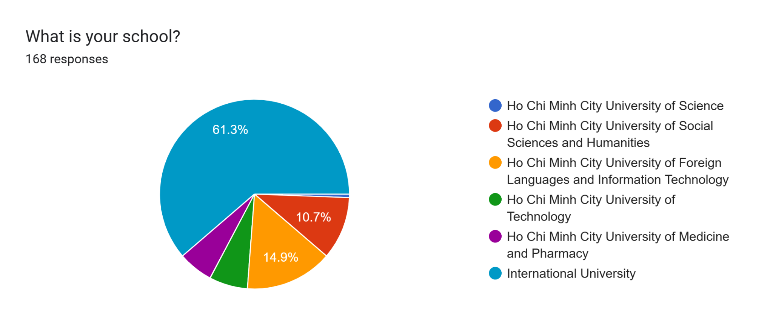

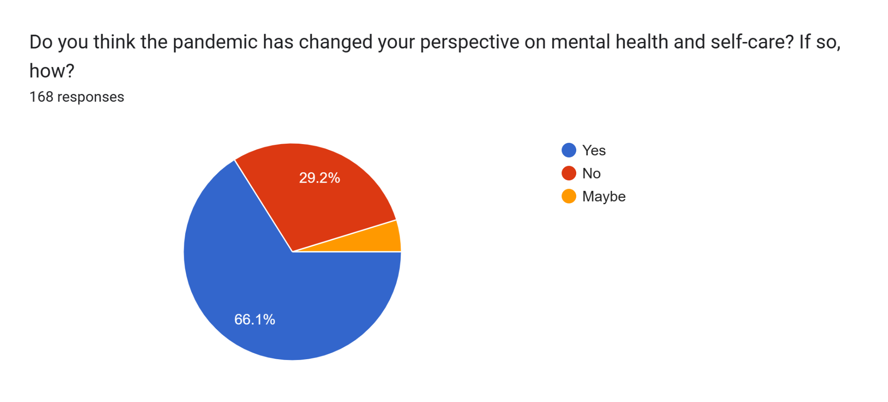

**Forms response chart. Question title: Are you concerned about the long-term mental health impacts of the Covid-19 pandemic?
. Number of responses: 168 responses.**

**Forms response chart. Question title: Do you believe additional support or resources would be helpful in addressing mental health challenges in the post-pandemic period?
. Number of responses: 168 responses.**

**Forms response chart. Question title: Has social isolation or distancing measures affected your mental well-being?
. Number of responses: 168 responses.**

**Forms response chart. Question title: Have you been able to maintain meaningful social connections despite the challenges of the pandemic?
. Number of responses: 168 responses.**

**Forms response chart. Question title: Have you experienced challenges in maintaining a work-life balance during the pandemic?
. Number of responses: 168 responses.**

**Forms response chart. Question title: Has remote work or study affected your mental health during the pandemic?
. Number of responses: 168 responses.**

**Forms response chart. Question title: Do you think the pandemic has changed your perspective on mental health and self-care?
. Number of responses: 168 responses.**

**Forms response chart. Question title: If applicable, have changes in your workplace, such as remote work or job insecurity, affected your mental health?
. Number of responses: 168 responses.**

**Forms response chart. Question title: Have you experienced changes in your sleep patterns or quality of sleep due to the pandemic?
. Number of responses: 168 responses.**

**Forms response chart. Question title: Have you sought professional help or counseling for mental health concerns related to the pandemic?
. Number of responses: 168 responses.**

**Forms response chart. Question title: Have you observed changes in your relationships with family and friends due to the pandemic's impact on mental health?
. Number of responses: 168 responses.**

1. **Ethical Considerations**

The study adhered to ethical guidelines, prioritizing participant confidentiality and anonymity. Informed consent was obtained, and participants were assured that their responses would be used solely for research purposes. The research aimed to contribute valuable insights into the mental health challenges faced by university students during the Covid-19 pandemic.

1. **Explanatory Notes on Key Findings**

*University Affiliation Distribution:*

The distribution of respondents across various universities provides a diverse representation of the student population, enhancing the generalizability of the study's findings.

*Changes in Perspectives on Mental Health and Self-Care:*

The survey revealed that 29.2% of participants reported a change in their perspective on mental health and self-care during the pandemic. Further qualitative research could explore the nature of these changes and their driving factors.

*Concerns about Long-Term Mental Health Impacts:*

A substantial 78% of participants expressed concerns about the long-term mental health impacts of the pandemic. Qualitative follow-up studies could delve into specific worries and perceptions related to long-term mental health.

*Perceived Need for Additional Support:*

While 78% acknowledged the need for additional support or resources, a notable 13.7% felt unsure. Exploratory research could elucidate the specific types of support students believe would be beneficial.

*Impact of Social Isolation on Mental Well-being:*

A significant proportion (79.2%) reported that social isolation or distancing measures had affected their mental well-being. Qualitative research could uncover the nuanced ways in which social connections contribute to mental health.

*Challenges in Maintaining Work-Life Balance:*

A substantial 81% reported challenges in maintaining a work-life balance. Further investigation could identify specific stressors and coping mechanisms related to academic and personal life.

*Impact of Remote Work or Study on Mental Health:*

The majority (64.9%) reported that remote work or study had affected their mental health. In-depth interviews or focus groups could explore the factors contributing to this impact.

*Changes in Sleep Patterns:*

A significant 72.6% reported changes in sleep patterns. Further research could identify the factors contributing to sleep disturbances and their implications on overall well-being.

*Seeking Professional Help:*

A notable 16.7% sought professional help for pandemic-related mental health concerns. Qualitative studies could explore the factors influencing this decision and barriers to seeking help.

*Observations of Changes in Relationships:*

The impact of the pandemic on relationships was acknowledged by respondents. Qualitative research could provide insights into the nature and dynamics of these changes.

By employing a mixed-methods approach, combining quantitative survey data with qualitative interviews or focus groups, a comprehensive understanding of the complex interplay between the pandemic and mental health among university students can be achieved.

1. **RESULTS**

Implementation of lockdown due to COVID-19 has increased the mental stress of the VNU-HCM universities populace since the authority did not ensure fundamental needs. Levels of anxiety and depression were found to have a critical impact on the population's mental health. Relatively high rates of symptoms of change in the respective areas of mental health (29.2%), the long-term mental health impacts of the pandemic (78%), social isolation or distancing measures had affected their mental well-being (79.2%), challenges in maintaining a work-life balance (81%), remote work or study had affected their mental health (64.9%), changes in sleep patterns (72.6%), and professional help for pandemic-related mental health concerns (16.7%) were reported in the general population during the COVID-19 pandemic in six universities from VNU-HCM. The closure of many organizations, including educational institutions, may increase the number of mentally depressed young people. In this study, we have analyzed human behavioral changes during the lockdown and found that a large number of people are suffering from stress, depression, short temper, etc. Many factors like gender, age, organizational, behavioral problems for work from home policy, diseases, and physical problems have been statistically analyzed.

1. **SUGGESTIONS**
2. **Take care of your mind**

Reduce stress triggers:

Keep your usual schedule. Maintaining a regular daily routine is vital to your mental health. In addition to keeping to a normal nighttime pattern, establish constant hours for meals, showering and getting dressed, work or study schedules, and exercise. Also set aside time for hobbies you love. This regularity might make you feel more in control.

Limit exposure to news media. Constant news about COVID-19 from all sorts of media might heighten anxieties about the illness. Limit social media that may expose you to falsehoods and misleading information. Also restrict reading, listening or watching other news, but remain up to speed on national and local guidelines. Look for credible sources, such as the U.S. Centers for Disease Control and Prevention (CDC) and the World Health Organization (WHO).

Stay occupied. Healthy diversions may pull you away from the loop of negative thoughts that fuel anxiety and despair. Enjoy pastimes that you can do at home, such as reading a book, writing in a diary, creating a craft, playing games or preparing a new dish. Or select a new project or clear up that closet you swore you'd get to. Doing something good to control anxiety is a healthy coping approach.

Focus on positive ideas. Choose to concentrate on the good aspects in your life, instead of obsessing on how horrible you feel. Consider beginning each day by noting things you are grateful for. Maintain a feeling of hope, learn to accept changes as they occur and attempt to keep challenges in perspective. · Use your moral compass or spiritual life for assistance. If you derive strength from a belief system, it might provide you solace during tough and uncertain times.

Set priorities. Don't get overwhelmed by establishing a life-changing list of things to accomplish while you're home. Set acceptable objectives each day and explain activities you may take to accomplish those goals. Give yourself credit for every move in the right direction, no matter how tiny. And understand that some days will be better than others.

1. **Connect with others**

*Build support and improve relationships:*

Make relationships. If you work remotely from home or you need to distance yourself from people for a period of time owing to COVID-19, avoid social isolation. Find time each day to build virtual friendships via email, SMS, phone or video chat. If you're working remotely from home, ask your co-workers how they're doing and offer coping methods. Enjoy virtual mingling and communicating to folks in your house.

If you're not completely vaccinated, be creative and safe while meeting with folks in person, such as going for walks, conversing in the driveway and other outside activities, or wearing a mask for interior events. If you are completely vaccinated, you may more securely return to numerous indoor and outdoor activities you may not have been able to perform due of the epidemic, such as meeting with friends and family. If you are in a region with a high number of persons with COVID-19 in the hospital, the CDC suggests wearing a mask inside in public or outside in crowded places or in close contact with unvaccinated people. For unvaccinated persons, outdoor activities that provide lots of distance between you and others represent a reduced risk of dissemination of the COVID-19 virus than inside activities do.

Do something for others. Find meaning in assisting the people around you. Helping others is a fantastic approach to assist ourselves. For example, email, text or phone to check on your friends, family members and neighbors – particularly those who are elderly. whether you know someone who can't go out, ask whether there's anything required, such as groceries or a prescription picked up.

Support a family member or friend. If a family member or acquaintance has to be confined at home or in the hospital due to COVID-19, come up with strategies to keep in touch. This might be via technological gadgets or the telephone or by sending a message to lighten the day, for example: Avoid stigma and prejudice. Stigma may make individuals feel alone and even abandoned. They may feel unhappy, upset and furious when friends and people in their community shun them for fear of catching COVID-19. Stigma hurts people's health and well-being in numerous ways. Stigmatized populations may frequently be denied the resources they need to care for themselves and their families during a pandemic. And those who are frightened about being stigmatized may be less likely to obtain medical treatment.

Persons who have suffered stigma associated to COVID-19 include persons of Asian heritage, health care personnel, those with COVID-19 and those freed from quarantine. People who are stigmatized may be ostracized or shunned, treated differently, denied career and educational chances, and be targets of verbal, emotional and physical abuse. You may lessen stigma by: · Getting the information about COVID-19 from trustworthy sources such as the CDC and WHO.

Speaking out if you hear or read erroneous claims regarding COVID-19 and particular persons or groups · Reaching out to those who feel stigmatized · Showing support for healthcare personnel.

1. **CONCLUSION**

The COVID-19 epidemic has forced the development of evidence-based therapies to enhance mental well-being. These treatments are crucial in addressing the mental health implications that have been encountered by frontline health workers who are confronting COVID-19-related hazards of occupational exposure and overburdened job stress. These experts are at the vanguard of the struggle against the virus, and their mental health is of critical significance.

In addition to the health professionals, immigrants and migrants have also been heavily impacted. They have been encountering antagonism, prejudice, or stigmatization related to their apparent association with COVID-19 and its fast worldwide growth. This has further aggravated their mental health concerns, making it even more vital to treat these issues.

The influence of social media COVID-19 coverage and usage on mental health outcomes cannot be underestimated. The continual deluge of information, combined with the possibility for higher psychological discomfort, has had a tremendous influence on people’s mental health. It is also vital to analyze the influence of social media in molding public perception and reaction to the epidemic.

Special groups such as children and adolescents, the elderly, and mental patients confront specific obstacles when accessing healthcare services that are presently under significant COVID-19-related stress and demand. These populations need particular attention and specialized treatments to guarantee their mental well-being during these trying times.

The COVID-19 pandemic has also underlined the necessity for mental health assistance and management in terms of pandemic outbreak emergency response. There are service delivery discrepancies in poor and middle-income nations, and solutions for strengthening health care systems and policies are required. The implications for mental health therapies and assessments of the present approach to the COVID-19 pandemic are areas that deserve additional inquiry and research.

Lastly, the socioeconomic imbalances in the mental health implications of the pandemic are a serious worry. These discrepancies are connected to financial hardship, unemployment created by the epidemic, disparity in accessing healthcare and critical health-related resources like food, housing, and water, and poor knowledge towards disease prevention and self-protection. Addressing these imbalances is a vital step towards safeguarding the mental well-being of all members of society during and after the COVID-19 epidemic.

1. **REFERENCE**

[**https://www.ncbi.nlm.nih.gov/pmc/articles/PMC7361582/**](https://www.ncbi.nlm.nih.gov/pmc/articles/PMC7361582/)

[**https://www.who.int/news-room/feature-stories/detail/the-impact-of-covid-19-on-mental-health-cannot-be-made-light-of**](https://www.who.int/news-room/feature-stories/detail/the-impact-of-covid-19-on-mental-health-cannot-be-made-light-of)

[**https://www.who.int/news/item/02-03-2022-covid-19-pandemic-triggers-25-increase-in-prevalence-of-anxiety-and-depression-worldwide**](https://www.who.int/news/item/02-03-2022-covid-19-pandemic-triggers-25-increase-in-prevalence-of-anxiety-and-depression-worldwide)

[**https://www.ncbi.nlm.nih.gov/pmc/articles/PMC7413844/**](https://www.ncbi.nlm.nih.gov/pmc/articles/PMC7413844/)

[**https://www.mayoclinic.org/diseases-conditions/coronavirus/in-depth/mental-health-covid-19/art-20482731**](https://www.mayoclinic.org/diseases-conditions/coronavirus/in-depth/mental-health-covid-19/art-20482731)

1. **APPENDIX**

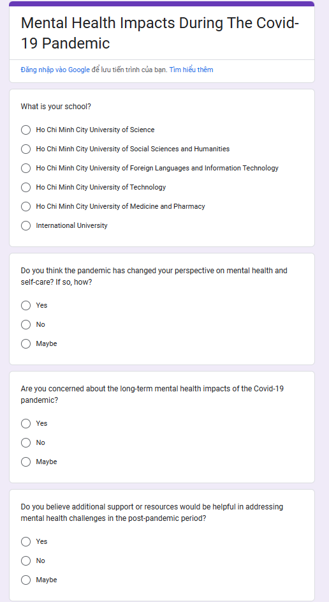

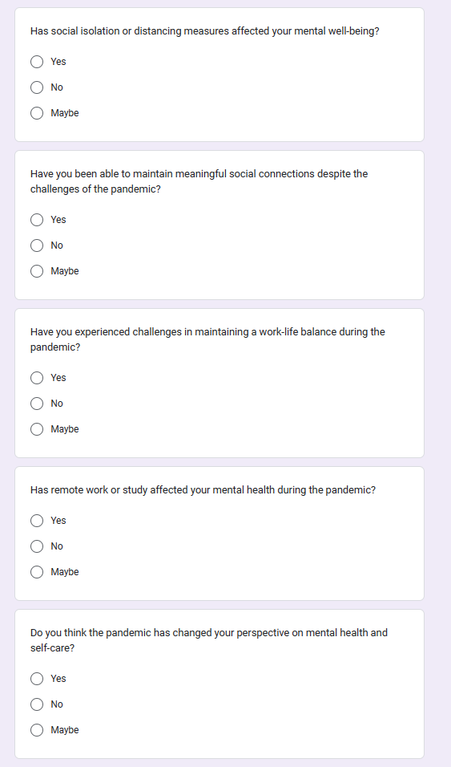

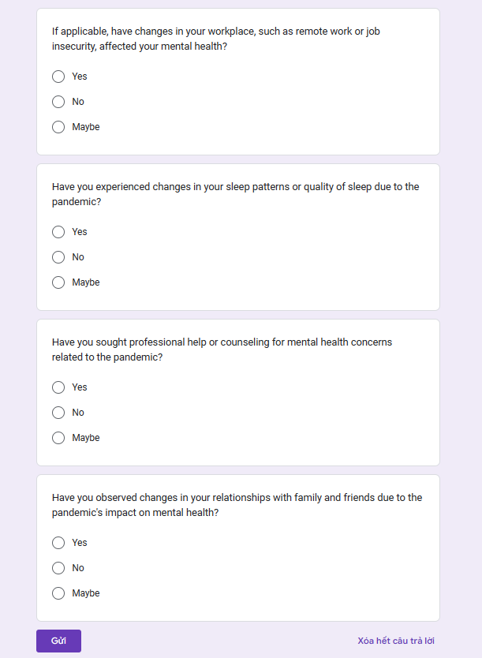

**GROUP MEMBER**

Đỗ Minh Duy - ITITSB22029 20%

Khánh Vy 20%

Vương Thiện Quang - EEACIU22232 20%

Nguyễn Anh Minh - ITITWE22033 20%

Mai Trọng Nguyên- IEIESB22005 20%